**SonarQube Installation and configuration guide**

|  |  |  |  |
| --- | --- | --- | --- |
| **Document Name** | **Version** | **Prepared by** | **Reviewed by** |
| SonarQube Installation and configuration guide | v.01 | Tarunendra Tripathi | Sumit Malhotra |
|  |  |  |  |

Contents

Introduction 2

Download and install sonarqube 2

Configuration Changes 2

Start/Stop SonarQube 2

SonarQube URL 3

Maven Dependency 3

# Introduction

This document contains the installation and configuration of SonarQube on RHEL environment.

# Download and install sonarqube

Download and install sonarqube as mentioned in below screenshot.

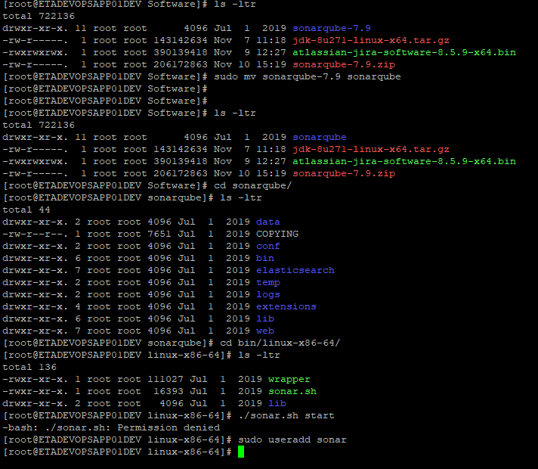

# Configuration Changes

Use below file for configuration changes

Conf/sonarqube.properties

# Start/Stop SonarQube

sh /bin/linux-x86-64/sonar.sh start

sh /bin/linux-x86-64/sonar.sh stop

# SonarQube URL

<http://10.191.159.48:9100/sonarqube>

admin/admin

# Maven Dependency

Use below snippet for maven depended project.

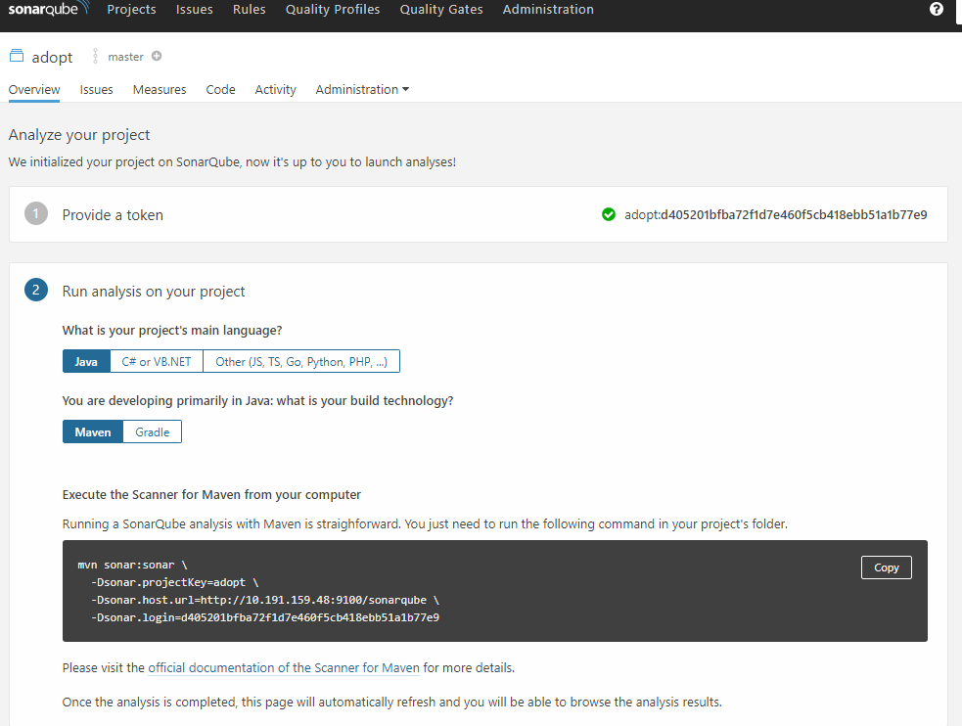

mvn sonar:sonar \

-Dsonar.projectKey=adopt \

-Dsonar.host.url=http://10.191.159.48:9100/sonarqube \

-Dsonar.login=d405201bfba72f1d7e460f5cb418ebb51a1b77e9